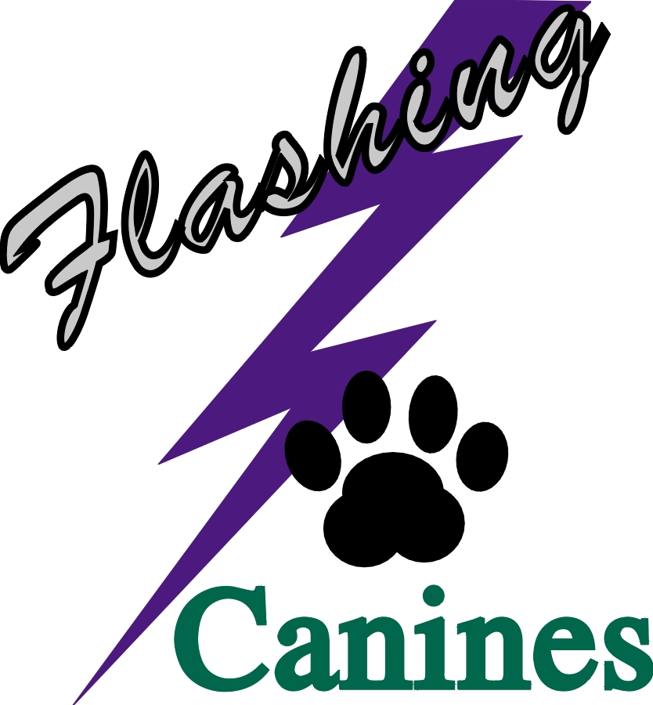 

The Flashing Canines

***Invite you to join us at our***

***3 Day September Trial***

*(A Limited AAC Sanctioned Agility Trial)*

*September 13th, 14th, & 15th, 2019*

*Redcliff, AB*

Outdoor Grass Surface – Rain or Shine, Wind or Snow

Opening Date: July 15th, 2019

Postmark Closing Date: August 16th, 2019

* Entries postmarked before the opening date will not be accepted *

**Electronic Timing**

**Rubberized Contacts**

**No One-Piece Jumps**

***WITH DISTINGUISHED JUDGES***

*Christina Sanders (Sherwood Park, AB) & Michelle Larson (Medicine Hat, AB)*

Classes Offered:

Team Challenge – 1 round

Standard - 2 rounds (Starters, Advanced, Masters- 1 Master Standard)

Challenge – 1 round (Masters)

Gamblers - 2 rounds (Starters, Advanced, Masters)

Jumpers - 2 rounds (Starters, Advanced, Masters)

Snooker - 2 rounds (Starters, Advanced, Masters)

Tentative Running Order:

|  |  |  |
| --- | --- | --- |
| **Friday, September 13th** | **Saturday, September 14th (SAM)** | **Sunday, September 15th**  **(MAS)** |
| Team Relay 1 | Standard 1 | Gamblers 2 |
|  | Gambles 1 | Challenge 1 (M) |
|  | Snooker 1 | Standard 1 (AS) |
|  | Jumpers 1 | Snooker 2 |
|  |  | Jumpers 2 |

**Trial Chair: Trial Secretary:**

***Michelle Larson*** Phone 403-928-8248 ***Linda Krochak*** Phone 403-502-0014

Email : [michellelarsonfk9@hotmail.com](mailto:michellelarsonfk9@hotmail.com) Email: [lkrochak@shaw.ca](mailto:lkrochak@shaw.ca)

|  |  |
| --- | --- |
| Entry Rules | * Emailed, mailed, or couriered entries will be accepted. We are also hoping to try online entries. Watch our Facebook page and website for updates. * Cheque, cash, or e-transfer must accompany entry (e-transfer to: [lkrochak@shaw.ca](mailto:lkrochak@shaw.ca) – password: agility) and be received prior to the closing date |
| Ribbons and Prizes | * Rosettes for Titles and Qualifying Rounds * 1st, 2nd, 3rd, and 4th place will receive flat ribbons |
| Veterinarian | * Cypress View Veterinary Clinic * 403-527-1825 |

**Pet Friendly Accommodations – Just a sample. Check online for additional pet-friendly accommodations**

|  |  |  |  |
| --- | --- | --- | --- |
| ***Home Inn Express***  20 Strachan Court SE  Medicine Hat, AB Phone: (403) 527-1749  Toll Free: 1-800-466-8356 (North America)  10% discount with CAA membership  **Pet Policy: no charge**  Please call to confirm pet policy and rates | ***Travelodge***  1100 Redcliff Dr. SW  Medicine Hat, AB  Phone: 1-403-527-2275  Reservation: 1-000-000-0000    CAA discount  **Pet Policy: $10.00 per dog**  Please call to confirm pet policy and rates | ***Comfort Inn & Suites***  2317 Trans Canada Way SE, Medicine Hat, AB  **Phone:** (403) 504-1700 **Fax:** (403) 527-1579 | ***Hampton Inn & Suites***  2510 Box Springs Blvd NW, Medicine Hat, AB  **Phone:** 1 (855) 976-2859 |

|  |
| --- |
| ***Camping***  Redcliff Municipal Campground  100 Block of 3rd Street N.W.  Cost:   * Tents: $20.00/day, maximum 14-day stay * Camper/Trailer/other RVs: $30.00/day * 48 sites   Services: electricity, showers/washrooms, water and sewer available within the campground  No reservations  Adjacent to baseball diamonds. Walking distance to swimming pool, football/soccer field, public library  Open May to end of September  Contact: 403-548-9253 |

**\*\*\*\* These rates are subject to change. Please call to confirm.\*\*\*\***

**Flashing Canines Official Entry Form:** Trial Dates: September 13th, 14th, and 15th, 2019

Return Completed Entry Form with Fees Payable to **Flashing Canines Agility Club** to Linda Krochak, 54 Northlands Pointe NE, Medicine Hat, AB T1C 0C3, or email entries and fees to: [lkrochak@shaw.ca](mailto:lkrochak@shaw.ca). We are hoping to do online entries through Agility Rocks. Watch our Facebook page and website for details

**Entries must be received no earlier than July 15th 2019 and may not be accepted after August 16th, 2019. Dishonoured cheques will be subject to a $20.00 fee**

|  |
| --- |
| **NAME: __________________________________________________________________________________________________**  **ADDRESS: _______________________________________________________________________________________________**  **CITY: ________________________________ PROVINCE: _____________________ POSTAL CODE: ___________________**  **PHONE: ______________________________ EMAIL: ___________________________________________________________**  **(Confirmations will be sent out by email after the closing date.) Has any of your information changed? (handler or dog) ______ Yes _______ No** |

**Dog #1 Dog #2 Dog #3 Dog #4**

|  |  |  |  |  |
| --- | --- | --- | --- | --- |
| **Dog Information** | **Name:________________**  **AAC #: _______________** | **Name:________________**  **AAC #: _______________** | **Name:________________**  **AAC #: _______________** | **Name:________________**  **AAC #: _______________** |
| **Handler Name:** |  |  |  |  |
| **Breed:** |  |  |  |  |
| **Birth Date (dd/mm/yy)** |  |  |  |  |
| **Height at Withers:** |  |  |  |  |
| **Dog Competes in:** | **Regular Specials Vets**  **Vet DD JH Rules** | **Regular Specials Vets**  **Vet DD JH Rules** | **Regular Specials Vets**  **Vet DD JH Rules** | **Regular Specials Vets**  **Vet DD JH Rules** |
| **Jump Height at Trial** | 4" 8" 12" 16" 20" 24” | 4" 8" 12" 16" 20" 24” | 4" 8" 12" 16" 20" 24” | 4" 8" 12" 16" 20" 24” |
| **Friday**  **(Check if entering)** | **Team Challenge _____**  **Preferred Partner:**  **Owner: _________________**  **Dog: _______________** | **Team Challenge _____**  **Preferred Partner:**  **Owner: _________________**  **Dog: _______________** | **Team Challenge _____**  **Preferred Partner:**  **Owner: _________________**  **Dog: _______________** | **Team Challenge _____**  **Preferred Partner:**  **Owner: _________________**  **Dog: _______________** |
| **Saturday (SAM)**  **(Circle Class and Level)** | **Gamblers 1**  **Starters/Advanced/Master/FEO** | **Gamblers 1**  **Starters/Advanced/Master/FEO** | **Gamblers 1**  **Starters/Advanced/Master/FEO** | **Gamblers 1**  **Starters/Advanced/Master/FEO** |
| **Standard 1**  **Starters/Advanced/Master/FEO** | **Standard 1**  **Starters/Advanced/Master/FEO** | **Standard 1**  **Starters/Advanced/Master/FEO** | **Standard 1**  **Starters/Advanced/Master/FEO** |
| **Snookers 1**  **Starters/Advanced/Master/FEO** | **Snookers 1**  **Starters/Advanced/Master/FEO** | **Snookers 1**  **Starters/Advanced/Master/FEO** | **Snookers 1**  **Starters/Advanced/Master/FEO** |
| **Jumpers 1**  **Starters/Advanced/Master/FEO** | **Jumpers 1**  **Starters/Advanced/Master/FEO** | **Jumpers 1**  **Starters/Advanced/Master/FEO** | **Jumpers 1**  **Starters/Advanced/Master/FEO** |
| **Sunday (MAS)**  **(Circle Class and Level)** | **Standard 2**  **Starters/Advanced/FEO**  **______________________**  **Challenge**  **Masters/FEO** | **Standard 2**  **Starters/Advanced/FEO**  **________________________**  **Challenge**  **Masters/FEO** | **Standard 2**  **Starters/Advanced/FEO**  **________________________**  **Challenge**  **Masters/FEO** | **Standard 2**  **Starters/Advanced/FEO**  **________________________**  **Challenge**  **Masters/FEO** |
| **Gamblers 2**  **Starters/Advanced/Master/FEO** | **Gamblers 2**  **Starters/Advanced/Master/FEO** | **Gamblers 2**  **Starters/Advanced/Master/FEO** | **Gamblers 2**  **Starters/Advanced/Master/FEO** |
| **Snooker 2**  **Starters/Advanced/Master/FEO** | **Snooker 2**  **Starters/Advanced/Master/FEO** | **Snooker 2**  **Starters/Advanced/Master/FEO** | **Snooker 2**  **Starters/Advanced/Master/FEO** |
| **Jumpers 2**  **Starters/Advanced/Master/FEO** | **Jumpers 2**  **Starters/Advanced/Master/FEO** | **Jumpers 2**  **Starters/Advanced/Master/FEO** | **Jumpers 2**  **Starters/Advanced/Master/FEO** |
| **Entry Fees**  **Note: You must pay the non-worker price if you do not complete the volunteer worksheet** | **Workers Package and Pricing:**  3-day: $120.00 $__________  Sat/Sun: $110.00 $__________  Jr. 3-day: $110.00 $__________  Jr. Sat/Sun: $100.00 $________  *************************  **Individual Runs:**  ____ x $15.00 = $__________  Jr: ____ x $13.70 = $_________  **Total** $__________  **************************  **Non-Worker Pricing**  Individual Runs:  ____ x $20.00 = $__________  Total Fee: $__________ | **Workers Package and Pricing:**  3-day: $120.00 $__________  Sat/Sun: $110.00 $__________  Jr. 3-day: $110.00 $__________  Jr. Sat/Sun: $100.00 $________  *************************  **Individual Runs:**  ____ x $15.00 = $__________  Jr. ____ x $13.70 = $_________  **Total** $__________  **************************  **Non-Worker Pricing**  Individual Runs:  ____ x $20.00 = $__________  Total Fee: $__________ | **Workers Package and Pricing:**  3-day: $120.00($__________  Sat/Sun: $110.00 $__________  Jr. 3-day: $110.00 $__________  Jr. Sat/Sun: $100.00 $________  *************************  **Individual Runs:**  ____ x $15.00 = $__________  Jr. ____ x $13.70 = $_________  **Total** $__________  **************************  **Non-Worker Pricing**  Individual Runs:  ____ x $20.00 = $__________  Total Fee: $__________ | **Workers Package and Pricing:**  3-day: $120.00 $__________  Sat/Sun: $110.00 $__________  Jr. 3-day: $110.00 $__________  Jr. Sat/Sun: $100.00 $________  *************************  **Individual Runs:**  ____ x $15.00 = $__________  Jr. ____ x $13.70 = $_________  **Total** $__________  **************************  **Non-Worker Pricing**  Individual Runs:  ____ x $20.00 = $__________  Total Fee: $__________ |
| **Total of All Dogs/All Fees:______________________________________** | | | | |

**Agility Association of Canada (“AAC”)  
Participation waiver and Release**

**AAC RedHandler Name**:

**Dog Name**: (the “**Dog**”) **AAC Dog ID#**:   
**Dog Name**: (the “**Dog**”) **AAC Dog ID#**:

**Dog Name**: (the “**Dog**”) **AAC Dog ID#**:

**Dog Name**: (the “**Dog**”) **AAC Dog ID#**:

In consideration of the acceptance of this entry by AAC and Flashing Canines Agility Club(the “Organizing Club”) and the opportunity to have the Dog participate, compete in and/or be judged at this event or trial (the “**Event**”), I, the undersigned, agree as follows:

1. I certify that I am the actual owner of the Dog, or that I am the duly authorized agent of the actual owner of the Dog and that the Dog is not a hazard to persons, property or other dogs.

2. I agree that AAC or the Organizing Club for the Event may refuse my entry for any reason that it deems to be sufficient.

3. I understand and acknowledge that participation in the Event carries certain risks, including, but not limited to injuries (including serous injuries and death) to myself, the Dog, another dog under my control or persons attending as my guests (my “**Related Parties**”), damage to property and other losses. I waive any and all claims that I have or may have in the future against, and release from all liability and agree not to sue AAC, the Organizing Club or any of the directors, executives, committees, representatives, employees, volunteers or agents of either AAC or the Organizing Club (the “**Personnel**”) for any injury, death, property damage or other loss that I or my Related Parties sustain due to any cause whatsoever, including negligence, breach of contract, breach of duty, statutory or otherwise, or mistakes or errors of judgment of any kind.

4. I assume full responsibility for the conduct of myself and my Related Parties during the entirety of the Event. I agree to indemnify and save harmless AAC, the Organizing Club and the Personnel from and against any and all claims that may be made against them or costs, fees, expenses or liability (including, without limitation, lawyers’ fees on a solicitor and own client basis) incurred by AAC, the Organizing Club or the Personnel that may arise due to:

(a) any act or omission of myself, my Related Parties or any party for whom I am liable at law; or

(b) aggressive behaviour by the Dog or any other dog under my control.

5. I have read, and do understand the rules of competition and the additional rules (if any) appearing in the trial schedule for the Event, as well as the policies of AAC pertaining to discipline (collectively, the “**Rules**”). I agree to abide by the Rules and to conduct myself and the Dog in accordance with the Rules. I understand that myself and/or the Dog may be subject to disciplinary procedures or sanctions for breach of the Rules and agree to respect and be bound by any disciplinary decision made by AAC.

6. I understand that AAC and/or the Organizing Club may, in the course of administering the Event or conducting its activities generally, collect, use or disclose my personal information and that any personal information collected, used or disclosed by AAC and/or the Organizing Club will be treated in accordance with AAC policy and applicable privacy and personal information laws. I hereby consent to the collection, use and disclosure by AAC and/or the Organizing Club of my personal information.

**Media Release & Rights of Privacy Waiver**

I Hereby Grant to AAC and its affiliated companies, representatives, agents and assigns, all rights and permission to use or appropriate his/her and their dog’s name, biography, likeness, photograph, voice, performing persona, or other indicia of identity for broadcast, telecast, cablecast, transmission or distribution in any format or media known now or in the future.

**Waiver of Rights to Privacy, Publicity & Personality**

Further, I hereby release Agility Association of Canada Inc, and its affiliates, representatives, agents and assigns from any claim or cause of action for invasion of the rights of privacy, right of publicity, right of personality, or any similar rights.

7. I have been given the opportunity to read and understand the terms of this Agreement before signing it, and have in fact done so. I understand that by signing this Agreement, I am restricting my legal rights and I sign this Agreement voluntarily and of my own free will.

Signature: __________________________________________________________

*Parent or Guardian must sign if the Handler is under 18 years of age.*

Date *(dd/mm/yy)*:____________________________________________________

**Entry not valid unless Agreement is signed, dated, and submitted with the correct fee.**

**Flashing Canines NEEDS YOUR HELP PLEASE!**

Flashing Canines depends on workers like you to make this event great!

Please check the jobs you would like to work. We will schedule you to work where you are needed and will not schedule you when you are running. If you are travelling we will not schedule the last event of the day (unless you let us know you are staying until the end. If you are travelling with someone who is not running a dog and would like to help, please let us know.

|  |  |
| --- | --- |
| **Workers Name:** |  |
| **Email:** |  |
| **Names of all dogs:** |  |
| **Instructions:** |  |
| **Travelling with:** |  |

|  |  |  |
| --- | --- | --- |
| **Day(s) please circle day** | **Do What?** | **Experienced / Will Learn** |
| Friday Saturday Sunday | GATE STEWARD- make sure dogs and handlers are lined up and ready to run. Announce height, division, and class changes. | Experienced Will Learn |
| Friday Saturday Sunday | POLE SETTER- reset bars when knocked down and at height changes, straighten chute, help raise/lower table/a-frame | Experienced Will Learn |
| Friday Saturday Sunday | LEASH RUNNER- take leashes from start to finish line. | Experienced Will Learn |
| Friday Saturday Sunday | SCRIBE- makes marks on scribe sheet when judge raises hand or calls out numbers | Experienced Will Learn |
| Friday Saturday Sunday | TIMER- uses e-timer to time a dog during the run | Experienced Will Learn |
| Friday Saturday Sunday | COURSE BUILDER- move obstacles between classes as directed by master course builder. | Experienced Will Learn |

Please check ALL the classes you have entered for ALL THE DOGS you will be running so that we can avoid scheduling conflicts. Complete one sheet per volunteer.

|  |  |  |
| --- | --- | --- |
| **Friday** | **Class** |  |
|  | Team |  |

|  |  |  |  |  |
| --- | --- | --- | --- | --- |
| **Saturday** | **Class** | **STARTER** | **ADVANCE** | **MASTERS** |
|  | Gamblers |  |  |  |
|  | Standard |  |  |  |
|  | Snooker |  |  |  |
|  | Jumpers |  |  |  |

|  |  |  |  |  |
| --- | --- | --- | --- | --- |
| **Sunday** | **CLASS** | **MASTER** | **ADVANCE** | **STARTER** |
|  | Standard |  |  |  |
|  | Gamblers |  |  |  |
|  | Snooker |  |  |  |
|  | Jumpers |  |  |  |

The Alberta Freedom of Information and Protection of Privacy Act; enacted January 1st, 2004; requires that consent be obtained for the collection and use of personal information. The information collected by the Flashing Canines Agility Club will be used for:

* Registering competitors in agility events; and
* Contacting competitors by email or mail for future agility events, such as trials and seminars.

All information collected from or pertaining to all competitors will be kept private and confidential unless authorized in writing by the competitor. All paper copies of entries containing personal information will be destroyed after a period of six months.

|  |
| --- |
| **Notice to Exhibitors** |
| * Exhibitors, through submission of entry, acknowledge they are knowledgeable of the rules and regulations of the AAC, including but not limited to the following: * This event is held under AAC Rules and Regulations and is open to all dogs being at least 18 months of age, pure bred or mixed breed, except bitches in season, aggressive dogs, or dogs suffering from any deformity or illness which may affect the dog’s physical or mental performance (Judges discretion). * **\*\* As of January 1, 2001, all dogs must have an AAC number before their entries will be accepted in an AAC sanctioned trial.** **Dogs with numbers pending will not be eligible to compete.** * Obstacles shall be chosen from those described in the current edition of the rules and regulations of the AAC and shall conform to AAC specifications. * No leads, collars, food, toys or any other aids or devices shall be permitted on the course at any time. Toys and food shall not be permitted within 10 feet of the ring entrance. * All dogs must be penned, crated or leashed when not in the ring. Please take responsibility for your dogs and children. Any exhibitor whose dogs and children create unnecessary disturbances or engage in unsafe or disruptive behaviour may be asked to leave the trial site. There will be no refunds for entries if an exhibitor is dismissed from competition for any reason. * Refunds will not be given for cancellations after the closing date except for bitches in season or injury to a dog or handler that physically prevents them from competing.   ***The Flashing Canines Agility Club reserves the right to refuse any entry*** |

**DRIVING DIRECTIONS**

Trial Site

To Calgary

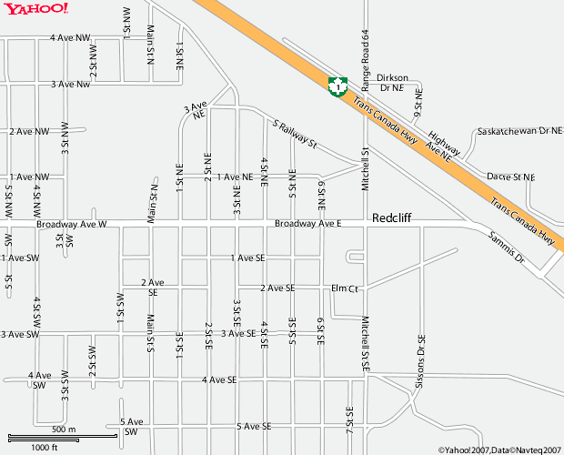

To Medicine Hat

**From Calgary** (approximately 3 hours):

1. Go East on Highway 1.

2. Upon nearing Redcliff, turn right to go onto 8th St. NW.

3. Turn left onto Broadway Avenue.

4. Turn right on 3rd St. SW to enter trial site parking area.

**From Medicine Hat** (approximately 15 minutes):

1. Go West on Highway 1.

2. Turn left at second major intersection to go onto Saamis Drive.

3. Turn right onto Broadway Avenue.

4. Continue into Redcliff, go approx. 1.66km on Broadway Avenue to 3rd St SW to enter trial site parking area.